|  |  |
| --- | --- |
| **Name:- Aryan Dilipbhai Langhanoja** | **Roll Number:- 92200133030** |
| **Subject Name and Code:-** Foundation Skills On Sensor Interfacing (01CT1103) | **Date of Experiment:- 18-12-2022** |

|  |  |
| --- | --- |
| Task:- |  |

Analog read serial and switch case

|  |  |
| --- | --- |
| Components: |  |

* Arduino Uno R3
* LED
* Jumper Wires (Male To Male).
* Potentiometer
* Bread Board
* Laptop Or PC

|  |  |
| --- | --- |
| About the Project:- |  |

* In thisproject, we are going to use Arduino to blink the LED. We will connect terminal-1 VCC to 5V and terminal-3 ground will be connected to GND.And middle pin is output Which is Connected to Analog pin A0.Because of potentiometer is generating 0 to 1023 values.we have to map it to 0 to 256.and further we have to map it from 0 to 3.

|  |  |
| --- | --- |
| Output (you circuit implementation):- |  |

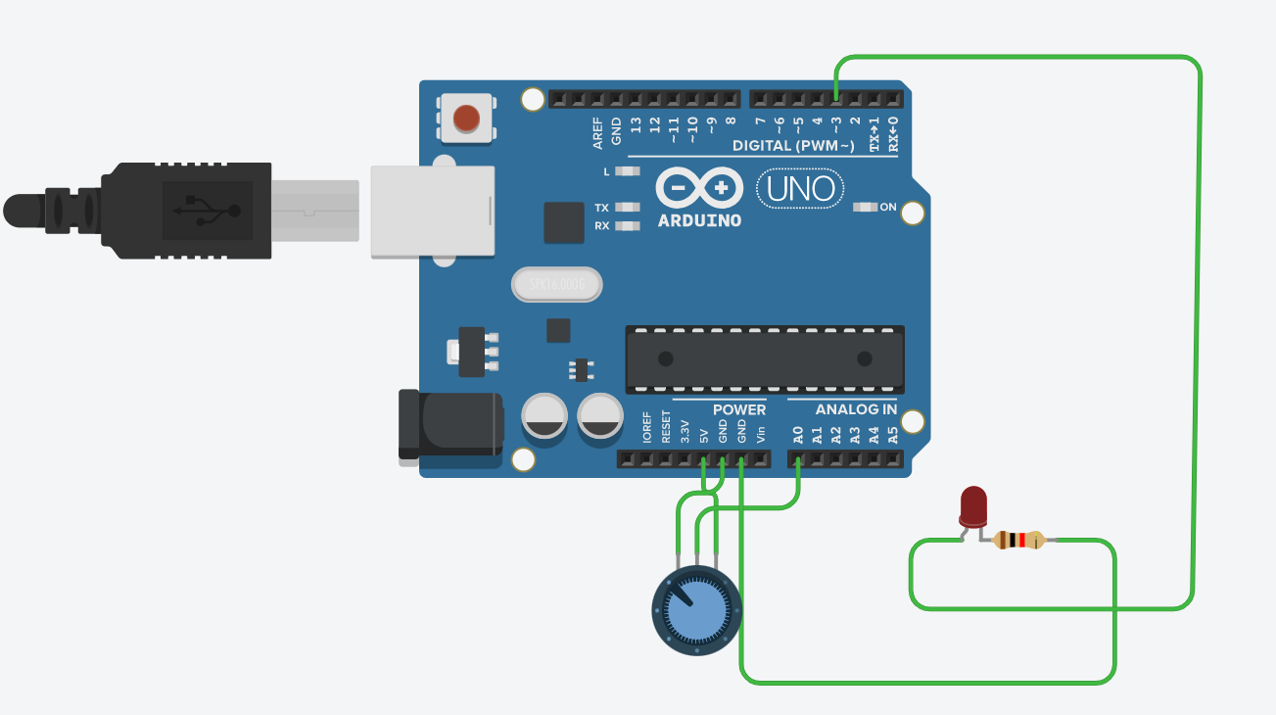

|  |  |  |
| --- | --- | --- |
| Schematic:- |  |  |

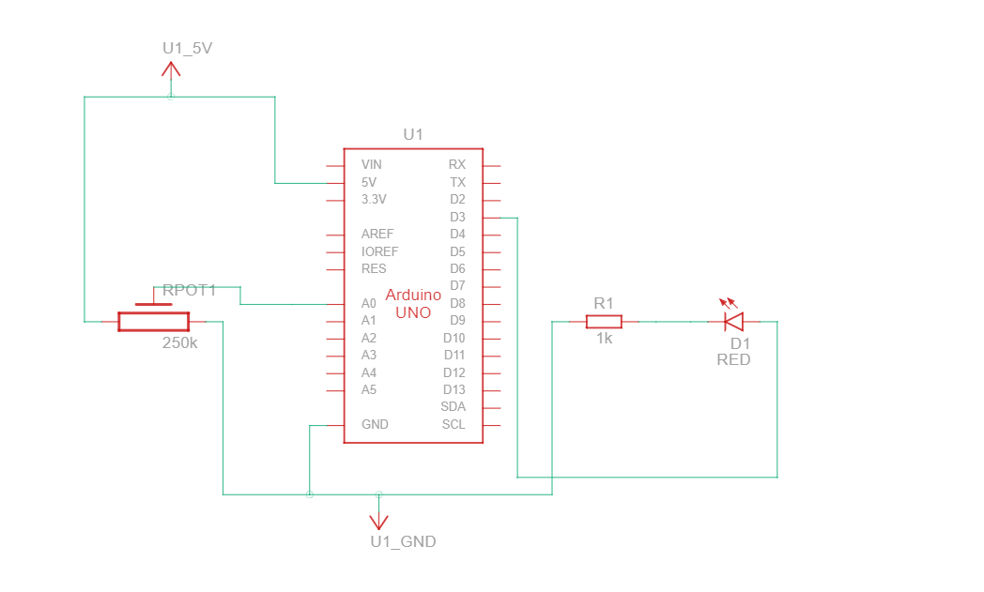

|  |  |
| --- | --- |
| Code:- |  |

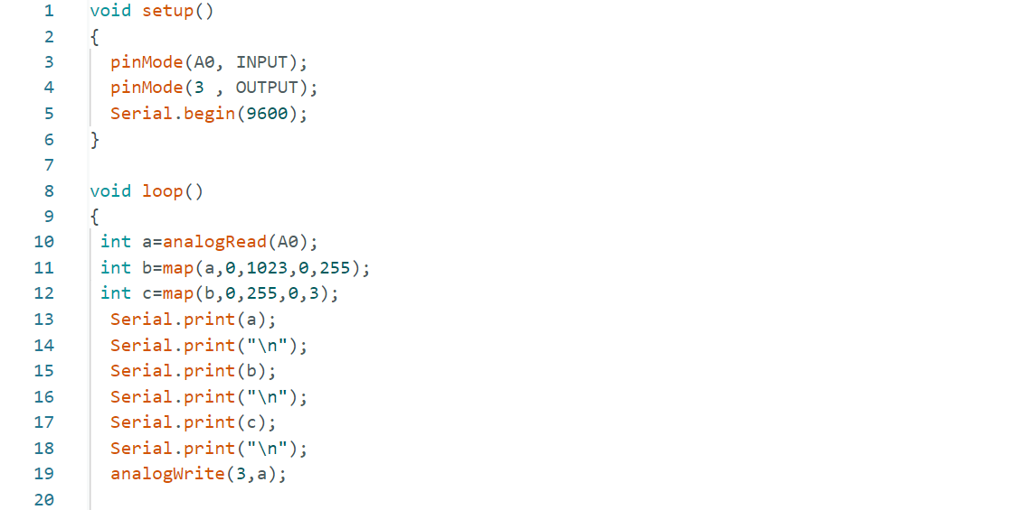

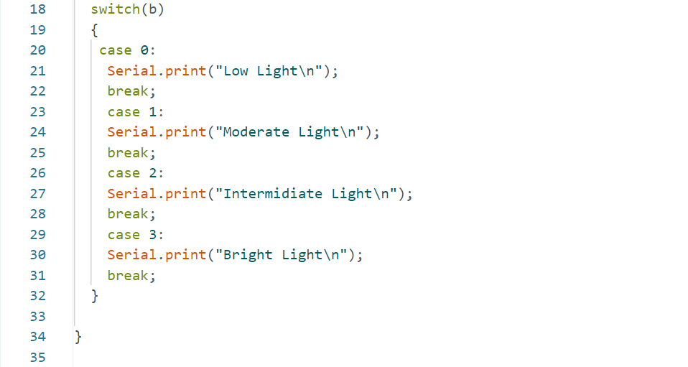

|  |  |
| --- | --- |
| Conclusion:- |  |

* In This Experiment, We Learnt Switch case.